ERD Sistem

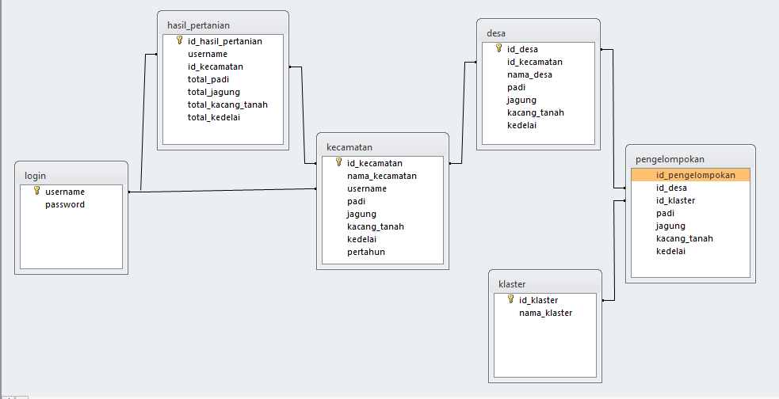

Alur Sistem SIPEHATAMAN

Storiboard Desain Layout

1. Login

Username

Password

Login

Selamat Datang

2. Dasboard

Header

Dasboard

Data Kecamatan

Pengelompokan

Logout

Total hasil padi

Total hasil jagung

Total hasil kacang tanah

Total hasil kedelai

Hasil padi....%?

Hasil jagung...%?

Hasil kacang tanah...% Hasil kedelai...%?

3. kecamatan

Header

Dasboard

Data Kecamatan

Pengelompokan

|  |  |  |  |  |  |  |
| --- | --- | --- | --- | --- | --- | --- |
| No. | Id_kecamatan | Nama_kecamatan | Hasil pertanian | | | |
| padi | jagung | Kacang tanah | kedelai |

kecamatan

4. desa

Header

Dasboard

Data Kecamatan

Pengelompokan

|  |  |  |  |  |  |  |  |
| --- | --- | --- | --- | --- | --- | --- | --- |
| No. | Id_desa | Id_kecamatan | Nama_desa | Hasil pertanian | | | |
| padi | jagung | Kacang tanah | kedelai |
| 1. |  |  |  |  |  |  |  |

desa